


Produce documents, reports and worksheets on a computer
D1.HGE.CL7.10
D1.HGA.CL6.07
D2.TGA.CL6.02
Trainee Manual






Produce documents, reports and worksheets on a computer

D1.HGE.CL7.10
D1.HGA.CL6.07
D2.TGA.CL6.02

Trainee Manual





Project Base
William Angliss Institute of TAFE
555 La Trobe Street
Melbourne 3000 Victoria
Telephone: | (03) 9606 2111
Facsimile: | (03) 9670 1330
Acknowledgements
Project Director: | Wayne Crosbie
Chief Writer: | Alan Hickman
Subject Writer: | Nick Hyland
Project Manager/Editor: | Alan Maguire
DTP/Production: | Daniel Chee, Mai Vu, Kaly Quach

The Association of Southeast Asian Nations (ASEAN) was established on 8 August 1967. The Member States of the Association are Brunei Darussalam, Cambodia, Indonesia, Lao PDR, Malaysia, Myanmar, Philippines, Singapore, Thailand and Viet Nam.
The ASEAN Secretariat is based in Jakarta, Indonesia.
General Information on ASEAN appears online at the ASEAN Website: www.asean.org.
All text is produced by William Angliss Institute of TAFE for the ASEAN Project on “Toolbox Development for Front Office, Food and Beverage Services and Food Production Divisions”.
This publication is supported by the Australian Government’s aid program through the ASEAN-Australia Development Cooperation Program Phase II (AADCP II).
Copyright: Association of Southeast Asian Nations (ASEAN) 2013.
All rights reserved.
Disclaimer
Every effort has been made to ensure that this publication is free from errors or omissions. However, you should conduct your own enquiries and seek professional advice before relying on any fact, statement or matter contained in this book. The ASEAN Secretariat and William Angliss Institute of TAFE are not responsible for any injury, loss or damage as a result of material included or omitted from this course. Information in this module is current at the time of publication. Time of publication is indicated in the date stamp at the bottom of each page.
Some images appearing in this resource have been purchased from stock photography suppliers Shutterstock and iStockphoto and other third party copyright owners and as such are non-transferable and non-exclusive. Clip arts, font images and illustrations used are from the Microsoft Office Clip Art and Media Library. Some images have been provided by and are the property of William Angliss Institute.
Additional images have been sourced from Flickr and SXC and are used under Creative Commons licence: http://creativecommons.org/licenses/by/2.0/deed.en

File name: TM_Produce_docs_reports_wsheets_on_a_comp_refined





Table of contents
Introduction to trainee manual 1
Unit descriptor 3
Assessment matrix 5
Glossary 7
Element 1: Determine presentation and format of document 11
Element 2: Produce document 25
Element 3: Print and deliver document 53
Presentation of written work 63
Recommended reading 65
Trainee evaluation sheet 67
Trainee self-assessment checklist 69

Introduction to trainee manual

To the Trainee
Congratulations on joining this course. This Trainee Manual is one part of a ‘toolbox’ which is a resource provided to trainees, trainers and assessors to help you become competent in various areas of your work.
The ‘toolbox’ consists of three elements:
- A Trainee Manual for you to read and study at home or in class
- A Trainer Guide with Power Point slides to help your Trainer explain the content of the training material and provide class activities to help with practice
- An Assessment Manual which provides your Assessor with oral and written questions and other assessment tasks to establish whether or not you have achieved competency.
The first thing you may notice is that this training program and the information you find in the Trainee Manual seems different to the textbooks you have used previously. This is because the method of instruction and examination is different. The method used is called Competency based training (CBT) and Competency based assessment (CBA). CBT and CBA is the training and assessment system chosen by ASEAN (Association of South-East Asian Nations) to train people to work in the tourism and hospitality industry throughout all the ASEAN member states.
What is the CBT and CBA system and why has it been adopted by ASEAN?
CBT is a way of training that concentrates on what a worker can do or is required to do at work. The aim is of the training is to enable trainees to perform tasks and duties at a standard expected by employers. CBT seeks to develop the skills, knowledge and attitudes (or recognise the ones the trainee already possesses) to achieve the required competency standard. ASEAN has adopted the CBT/CBA training system as it is able to produce the type of worker that industry is looking for and this therefore increases trainees’ chances of obtaining employment.
CBA involves collecting evidence and making a judgement of the extent to which a worker can perform his/her duties at the required competency standard. Where a trainee can already demonstrate a degree of competency, either due to prior training or work experience, a process of ‘Recognition of Prior Learning’ (RPL) is available to trainees to recognise this. Please speak to your trainer about RPL if you think this applies to you.
What is a competency standard?
Competency standards are descriptions of the skills and knowledge required to perform a task or activity at the level of a required standard.
242 competency standards for the tourism and hospitality industries throughout the ASEAN region have been developed to cover all the knowledge, skills and attitudes required to work in the following occupational areas:
- Housekeeping
- Food Production
- Food and Beverage Service
- Front Office
- Travel Agencies
- Tour Operations.
All of these competency standards are available for you to look at. In fact you will find a summary of each one at the beginning of each Trainee Manual under the heading ‘Unit Descriptor’. The unit descriptor describes the content of the unit you will be studying in the Trainee Manual and provides a table of contents which are divided up into ‘Elements’ and ‘Performance Criteria”. An element is a description of one aspect of what has to be achieved in the workplace. The ‘Performance Criteria’ below each element details the level of performance that needs to be demonstrated to be declared competent.
There are other components of the competency standard:
- Unit Title: statement about what is to be done in the workplace
- Unit Number: unique number identifying the particular competency
- Nominal hours: number of classroom or practical hours usually needed to complete the competency. We call them ‘nominal’ hours because they can vary e.g. sometimes it will take an individual less time to complete a unit of competency because he/she has prior knowledge or work experience in that area.
The final heading you will see before you start reading the Trainee Manual is the ‘Assessment Matrix’. Competency based assessment requires trainees to be assessed in at least 2 – 3 different ways, one of which must be practical. This section outlines three ways assessment can be carried out and includes work projects, written questions and oral questions. The matrix is designed to show you which performance criteria will be assessed and how they will be assessed. Your trainer and/or assessor may also use other assessment methods including ‘Observation Checklist’ and ‘Third Party Statement’. An observation checklist is a way of recording how you perform at work and a third party statement is a statement by a supervisor or employer about the degree of competence they believe you have achieved. This can be based on observing your workplace performance, inspecting your work or gaining feedback from fellow workers.
Your trainer and/or assessor may use other methods to assess you such as:
- Journals
- Oral presentations
- Role plays
- Log books
- Group projects
- Practical demonstrations.
Remember your trainer is there to help you succeed and become competent. Please feel free to ask him or her for more explanation of what you have just read and of what is expected from you and best wishes for your future studies and future career in tourism and hospitality.

Unit descriptor
Produce documents, reports and worksheets on a computer
This unit deals with the skills and knowledge required to Produce documents, reports and worksheets on a computer in a range of settings within the hotel and travel industries workplace context.
Unit Code:
D1.HGE.CL7.10
D1.HGA.CL6.07
D2.TGA.CL6.02
Nominal Hours:
25 hours

Element 1: Determine presentation and format of document
Performance Criteria
1.1 Select software appropriate to the nature of the document to be produced
1.2 Select appropriate layout and style of document consistent with enterprise guidelines
1.3 Discuss format and presentation of document with appropriate person

Element 2: Produce document
Performance Criteria
2.1 Produce document in required style and format
2.2 Produce document within designated timelines
2.3 Save document regularly to avoid loss of data
2.4 Information from same or other software packages is integrated as required
2.5 Proof read draft document prior to printing

Element 3: Print and deliver document
Performance Criteria
3.1 Utilise printing function
3.2 Proofread document
3.3 Make any necessary modifications to document to improve appearance and meet required specification/s
3.4 Print and present documents according to requirements

Assessment matrix
Showing mapping of Performance Criteria against Work Projects, Written Questions and Oral Questions
The Assessment Matrix indicates three of the most common assessment activities your Assessor may use to assess your understanding of the content of this manual and your performance - Work Projects, Written Questions and Oral Questions. It also indicates where you can find the subject content related to these assessment activities in the Trainee Manual (i.e. under which element or performance criteria). As explained in the Introduction, however, the assessors are free to choose which assessment activities are most suitable to best capture evidence of competency as they deem appropriate for individual students.

 |  |  | Work Projects | Written Questions | Oral Questions
Element 1: Determine presentation and format of document
1.1 | Select software appropriate to the nature of the document to be produced |  | 1.1 | 1,2 | 1
1.2 | Select appropriate layout and style of document consistent with enterprise guidelines |  | 1.2 | 3,4 | 2
1.3 | Discuss format and presentation of document with appropriate person |  | 1.3 | 5,6 | 3
Element 2: Produce document
2.1 |  | Produce document in required style and format | 2.1 | 7 | 4
2.2 |  | Produce document within designated timelines | 2.2 | 9,10 | 5
2.3 |  | Save document regularly to avoid loss of data | 2.3 | 11,12 | 6
2.4 |  | Information from same or other software packages is integrated as required | 2.4 | 13 | 7
2.5 |  | Proof read draft document prior to printing | 2.5 | 14 | 8
Element 3: Print and deliver document
3.1 | Utilise printing function |  | 2.1 | 15 | 9
3.2 | Proofread document |  | 2.2 | 16,17 | 10
3.3 | Make any necessary modifications to document to improve appearance and meet required specification/s |  | 2.3 | 18 | 11
3.4 | Print and present documents according to requirements |  | 2.4 | 19,20 | 12

Glossary
Term | Explanation
Amendment | A change or improvement in a document
Backup | A method of storing files for use in an emergency. The backup medium includes tape, disk or CD
Back-up system | A system used to store information for security purposes in case the computer system crashes
Byte | 8 bits
CD-ROM | Compact Disc Read Only Memory, which enables the storage of large amounts of text or data
CD-R | Compact Disc Recordable
CD-RW | Compact Disc Rewritable
Database | A computer software program used to store and organise a range of records or data
Data storage | The saving of data to a device such as a floppy disk, CD-ROM, hard drive or a back-up system
Defrag | Defragmentation is the process of locating the non-contiguous fragments of data into which a computer file may be divided as it is stored on a hard disk, and rearranging the fragments and restoring them into fewer fragments or into the whole file
Digital camera | A camera that converts photos into digital images that can be loaded directly onto a computer
Directories | Tables that contain file information such as name, file, size, time and date of last modification
DVD | Digital Versatile Disc
File generation | Creation of a new file for information, either on the computer or in a filing cabinet
Floppy-disk drive | The drive into which a floppy disk may be placed to either save information or read the information stored on it
Hard Copy | The output from software applications printed and stored on paper
Hard drive | The drive within a computer that stores information and enables the computer to run
Inventory | A record of items in stock. This is used to track consumables or to accurately describe devices
Keyboard | An input device with a set of keys used to enter information into a computer
Log-on | The use of a password to open or access files on a computer system
Manufacturer’s guidelines | A booklet setting out the manufacturer’s conditions of use for a piece of equipment
MB | Megabytes
Modem | A piece of equipment that enables the transfer of information from one computer to another via a telephone line or communications cable
Numerical key pad | Set of number keys on the keyboard
Printer | A device that prints text or graphics on paper or other media
Print Server | A network node which stores print jobs and then passes them to the printer. This action frees up the network from the slow printer output speed causing network congestion
Printer Bubble Jet | A printer which uses the process of spraying the ink onto the page by superheating a bubble of ink to eject the spray onto the paper
Printer Dot Matrix | An impact printer that uses a series of pins to press an inked ribbon onto the paper surface to create a character or image
Printer Driver | The software the printer uses to interpret the signals from the various applications that have the ability to output hard copy
Printer Impact | A printer that forms the characters and images on the paper by physical contact. They can be used to make a real time carbon copy
Printer Ink Jet | A non-impact printer that sprays the ink onto the paper through a series of fine nozzles
Routine maintenance | Ensuring that computers and other equipment are looked after, for example, by replacing consumables, clearing paper jams etc,
Scanner | A piece of equipment that copies a document or image directly into a computer
Spreadsheet | A computer software program used to store and calculate lists of numbers or statistics
Sub-directories | Directories located within another directory
Technology consumables | Paper, toner, bulbs and other items that must be constantly replaced as they are used or consumed by office equipment
Zip drive | A high-capacity disk drive, similar to a floppy drive

Element 1:
Determine presentation and format of document

1.1 Select software appropriate to the nature of the document to be produced

Introduction
This workbook will explore the different types of documents, reports and worksheets that are commonly prepared in a hospitality establishment.
Before we look the various documents themselves, it is important to identify the different types of technology and software that is required to produce them.
In order to select the right technology and software to complete a task, it is important to understand the functions of the office equipment and each type of software. When starting a new job or when a new piece of equipment is purchased, you should be trained in the main functions of the equipment, how to operate the equipment, Occupational Safety and Health and issues and routine maintenance.

Selecting the right technology and software
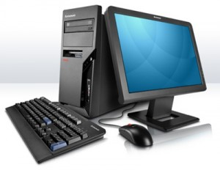
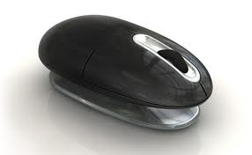


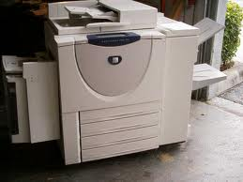
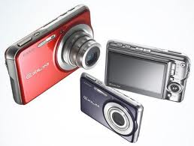
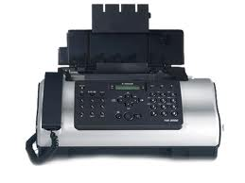

Hardware | Software applications
Computers, including laptops  Digital cameras  Zip drives  Modems  Printer/scanner/photocopier combination  Facsimile  Paging equipment  Calculators  Audio-transcribing machine  Telephone answering machines  External hard drives  Ergonomical mouse | Email and Internet browsers (Outlook)  Word processing (Microsoft Word)  Spreadsheets (Excel)  Databases (Excel)  Work project  Accounting packages (MYOB)  Presentation packages (PowerPoint)  Manage files (Office Manager).

Each organisation will have their own specific brands of technology and software to meet their individual and departmental needs; however they are consistent across brands and suppliers.

1.2 Select appropriate layout and style of document consistent with enterprise guidelines

Introduction
Different hospitality properties will have different needs for office documents although there is bound to be some degree of sameness across the industry.
This section identifies the different types of documentation that may be found in hospitality and general office environments.
As part of their daily duties, hotel staff will have to process documents in accordance with enterprise procedures and within required timelines.
Before producing any documents it is standard operating procedure to confirm the document requirements. This includes clarifying document purpose, intended audience and presentation requirements with the relevant personnel, and ensuring that all necessary organisational requirements are complied with.
This section will identify a number of different documents that are commonly used in a work environment. Section 2.1 of this manual will discuss in detail procedures associated with each of these documents.

Types of hospitality documents
Hospitality specific documents that may be prepared include:
- Guest mail – incoming and outgoing, domestic and international, normal post or special delivery requirements. Most accommodation properties offer guests this service. Stamps, insurance, priority payments, costs for satchels etc. are charged-back to their room and the account settled on departure
- Customer records – internal files such as guest history, profile, accounts, folios, and internal charges documents and vouchers need to be processed constantly.
- Electronic systems reduce some of the requirements in this area, but there is always a need to process any hard copy documents that the guest actually signs to verify receipt of goods/service. These hard copy documents continue to provide ‘proof of purchase’ where the customer queries a charge even in an electronic environment

- Incoming and outgoing correspondence relating to the operation of the establishment. This can include sending out quotations, sending out accounts for payment, responding to requests from various individuals, groups and organisations about the property, especially booking queries and complying with various governmental requirements
- Files. These can be paper-based or electronic and include correspondence, advertising, guest-related documents, advanced bookings (restaurant, accommodation, functions) as well as a range of files established by management to facilitate the operation of the business and tracking of its actual performance
- Letters in response to queries, complaints and congratulations, plus others as requested by management. Some letters may be form letters while others will be unique in nature

- Facsimiles (faxes). You may be required to prepare general distribution faxes, or draft specific draft responses to nominated faxes. The use of faxes seems to be declining in favour of e-mails for instant communication, but they nonetheless continue to be an important communication tool for business and an important vehicle for both receiving and sending some documents
- Memos – internal memos from various departments and managers. Processing can include producing the memo as well as distributing it as required. A pro forma is used with the specific contents varying according to need
- Reports. This can involve working in conjunction with the night auditor, or the production of monthly operational reports, or one-off proposals for action
- Menus – for all areas of the venue including function menus, and room service menus
- Banquet orders for forwarding to the relevant suppliers and distributing to relevant internal departments who are involved with the banquet/function
- Financial records as determined by management
- Invoices sent out by the venue requiring payment for goods and services supplied by the property
- Receipts acknowledging receival of payment for goods and services rendered, or for advanced deposits forwarded by guests, conference holders, tour operators and function organisers
- E-mail. This can be general broadcast e-mails advising customers of special deals, as well as individual responses to individual queries.
There may be other types of documents that are prepared to meet the needs of individual properties and departments. However the common ones are generic across industries and sectors.

Types of generic documents
Whilst the previous pages focused on hospitality examples, there are other generic documents, commonly prepared in an office environment, that you may be required to prepare including:
Memos
A memo (short for ‘memorandum’) is a piece of correspondence used internally within an organisation for staff to send written messages to one another. Intra-office e-mails are replacing these to some extent in some organisations, but as they say, “the paperless office is a long way away!”
Faxes
The proper name for these is facsimiles but few people use the full name.
These are documents, either printed or handwritten, sent over the telephone lines to another fax machine.
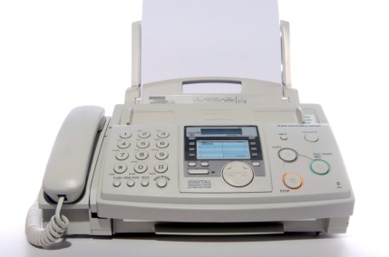
Cover Sheet
There is usually a ‘cover sheet’ that identifies:
- The sender - by personal and company name
- The recipient - by personal and company name
- The number of page being transmitted
- The date
- The topic.
There are often a couple of sentences asking that if the wrong person or wrong company receives the fax that they send it back.
The cover sheet can be accompanied by numerous other printed sheets. Faxes will transmit graphics, pictures and, where the computer system will support it; they may be generated and sent from a computer.
Letters
These can be business or official: a generic term for them is ‘correspondence’.
Business
These letters may be repetitive in nature (informing or acknowledging something), or they may be unique in style responding to a specific set of circumstances.

Official
These may have a legally binding effect and often demand specific authority to create them, and certain signatures before posting. Examples include:
- Offers
- Contracts
- Tender documents
- Acceptances
- Responses to certain allegations or assertions.

Standard form letters

These are standard pro forma letters that have been developed by the venue over time to respond to regularly occurring events such as complaints, receipt of advanced deposits, notifying guests of lost and found items, refusing a booking, personal references etc.
Envelopes
You may be required not only to produce envelopes for establishment business, but on some occasions you may be asked to help with mail-outs for guests, especially where there is a conference.
Agendas
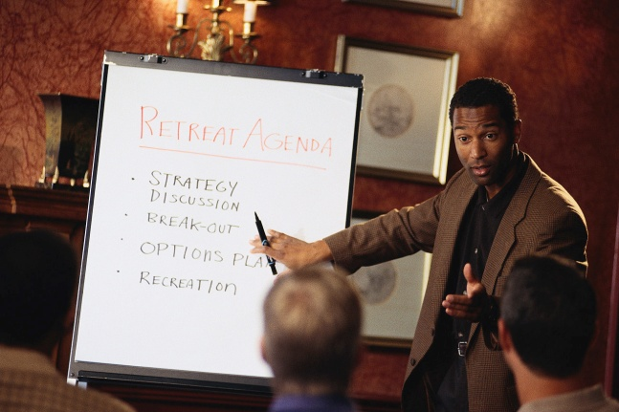
An agenda is an outline of the items to be covered at an upcoming meeting. There will most likely be pro-formas of these at your workplace to speed the process up. You will usually be required to get these printed and distributed a set number of days before each meeting so people can prepare for various items that will be raised.
There will usually be a distribution list for the agendas, and you may be required to attach various other papers to the agenda. These other papers may be briefing papers for items to be discussed, quotations, reports from various departments or consultants, financial information, items of correspondence etc.
Minutes
These are a written record of a meeting. You may be required to ‘take the minutes’ or they may be taken by the secretary of the meeting and then given to you to type up. When they are typed, you must distribute them as required to those who attended the meeting and perhaps other relevant people. E-mail is proving to be a popular way to disseminate these.
Briefing papers
These are written ‘reports’ on research findings done by an individual or by a group of people. This research has usually been asked for by their boss, or by some committee so as further informed discussion can take place about a certain issue. These briefing papers may have to be sent out with the agendas, or they can be ‘stand alone’ type documents.
Short report
These are similar to briefing papers with a main difference being that they not only present findings but also present various recommendations for future action based on the information contained in them.
They may also contain the methodology used for the research and appendices of various related data.
Simple one page flyers
You may be required to produce advertising material such as flyers intended either for in-house or external use to promote upcoming or current events or special deals.

Potential audiences

The nature, tone and terminology used in documents will alter depending on the various audiences being addressed.
Potential audiences for the wide range of documents include:
- Customers, guests and those who attend parties, conferences and seminars. This covers a whole range of documentation from minutes of meetings they have held, to typing up press releases for them, and even the production of special menus, name tags, seating plans and maps
- We may be writing to respond to complaints, or writing to thank guests for their letters commending us on our service. We may write to established clients making special offers to them. We may write to new guests offering our facilities and promoting what we have to offer
- We will often write to guests to send them an account
- Staff – covering inter-departmental reports, notifications, memos
- Suppliers – confirming orders, varying standing orders, complaining, seeking clarification of charges, issuing requests for tenders, seeking quotes, setting and disseminating purchasing standards
- Media. We may regularly contact various media outlets with news stories or articles we hope will catch the editor’s interest and bring some useful public relations exposure
- Agencies for staffing needs, engaging entertainment for the venue
- Government bodies to respond to demands or to comply with legislative requirements.
Organisational requirements
Organisations will have their own requirements, and while nearly all of them are very, very similar there will be small variations between venues. These may be based on head office dictates, or they may simply be personal likes and dislikes of the owner/manager.
Areas involved include:
Letterheads
Nearly all properties will have their own letterheads and you may be required to use these for letters. Traditionally, properties only use a letterhead for the first page of a letter, and then use ‘normal’ paper – called ‘followers’ – for the remaining pages. Followers have no letterhead on them and are plain pages with no markings.
They are cheaper than letterheads and allow more space for correspondence.
With compliments slips
Many venues have a ‘with compliments’ slip that accompanies mailouts. There may or may not be a set rule for when these are used. Commonly they are included when brochures or other material are sent out in an envelope. In some cases they are used in lieu of a letter.

Company envelopes
Many establishments have their own company envelopes, usually in a variety of sizes and styles. All mail sent is posted in these envelopes, with accounts usually going out in clear front style.
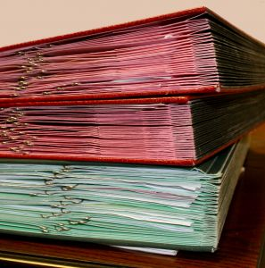
Some properties also have replied paid versions to enable guests and other contacts to return material (cheques, questionnaires) free of charge.
Keeping of copies
Many places will have a ‘correspondence’ file where ‘correspondence out’ (and ‘in’) may be filed. A hard copy of what has been sent is kept here in date and alphabetical order. Computer files also provide another copy.
Mail/postal book
Not every establishment uses this, but its use is not uncommon. It is used to record all outgoing mail, but more commonly kept when stamps (compared to franking, bulk mail, 'postage paid' imprinting) are stuck on the letters, so as to provide an audit of stamps used. This book will record purchases of stamps and stamp sales to staff/guests. Mail that is posted is listed by date, addressee details, type of letter or article, special comments, and postage amount.
Document processing tasks
The tasks involved in processing documents can include:
- Recording incoming or outgoing documents including mail, packages, accounts, reports, faxes and e-mails. There may be separate Mail In and Mail Out books that need to be completed. These detail incoming and outgoing mail by addressee, date received or sent. Where guest mail is sent on behalf of the guest there will also be a need to record the costs involved so these can be recouped from the guest

- Filing, including electronic filing, of correspondence, guest and reservation details, brochures and price lists, catalogues and personal contact details for guests, staff, suppliers, support industries, emergency services, service industries, tourist attractions and bodies, government bodies and local authorities
- Mailing, including bulk mailing for the establishment and on behalf of guests, and picking up mail from post boxes. The people who produce the documents are often responsible for making sure those documents are forwarded, sent and distributed. Bulk mail situations will occur, for example, where members of a Loyalty Club (or similar) are sent a newsletter, a special offer, or an update
- Photocopying for staff, departments, management and guests, and then adding copies to relevant files
- Faxing for staff, departments, management and guests. There may be a need to complete a Fax Register that records the faxes that were sent (who to, time, content, confirmation of ‘sent fax’) and the faxes that were received
- Collating and binding of reports
- E-mailing in response to incoming requests from guests and potential guests, travel agencies, tour wholesalers, airlines, coach companies, and other accommodation facilities. E-mails are becoming an increasingly popular way for clients to contact the property and either make enquiries or lodge bookings. Any property that offers online facilities must make sure these facilities are constantly monitored so that appropriate and timely responses can be made.

1.3 Discuss format and presentation of document with appropriate person

Introduction
Each organisation will have their own formats and styles that are to be selected when preparing and presenting various documents.
These are normally established to ensure consistency of brand and message as well as to ensure compliance with legal and company policies and procedures.
Appropriate person

There are a number of people who may need to approve the format and presentation used in preparing documents.
This includes, but is not limited to:
- Supervisor
- Originator of document
- Project leader
- Colleagues
- Intended client – as an initial draft.
Procedures and standards

Enterprise procedures and standards may relate to:
- Who has responsibility for producing and handling documents
- The writing style and format to be used
- Who has authority for authorising documents and signing them prior to despatch
- Filing and storing copies of documents
- Identification of (blank and pro forma) documents that need to be prepared on a regular basis such as rosters and management reports.

Writing styles

Given the differences in the nature of people to whom we may well be expected to write, it stands to reason that we may be required to apply different writing styles from time to time.
Writing to persuade
Here the aim is to influence the reader and three options present themselves.
We can make an:
- Emotional appeal – which is an appeal to the senses
- Factual appeal – which is an appeal to the intellect
- Appeal to authority – which appeals to the individual’s sense of status and self-esteem.
Having made your attempt to persuade your reader it is always important to identify the action that they should take. This may be to send a cheque, ring and make a booking, enquire for more information by ringing XYZ number, call in and ask for James, fax back the attached sheet etc.
Writing to develop an argument
Ensure you think clearly before you begin to write, and then write clearly (realise too, that in most cases someone else will have written the letter, but there are always times when the manager gets you to do it – “You know what I want, just send him a letter. I’ll leave it up to you.”).
Your argument must be sound, logical and convincing, and it is essential that you clarify and identify the problem being addressed.
Any opinions given must be based on facts collected through research, not just beliefs or hunches, and it may be advantageous to present both sides of the argument, and then show the merit of the one you wish to achieve.
When writing this style of letter, you must be very aware that whatever you put in writing is a permanent record.
It is always sound business practice to have someone in authority read, authorise and sign this type of letter before posting it.
Writing to inform
It is vital to consider your reader or audience and to determine, for instance, whether or not they are technically oriented.
This will influence your choice of language and tone, and enables appropriate communication of your message.
You should also strive to balance the information sent. Too much information may confuse your audience, while too little may puzzle or even give cause for disbelief.

Usually the point which has greatest impact, and which you want to be remembered, should be on the top, left-hand corner of the page.
In this style of letter it is important that you identify in your writing what is opinion and what is fact. The aim is that you should deliver an objective presentation based on facts that the reader can check.
Clarification of requirements
The clarification of requirements includes confirming the following aspects with the person who wants the document produced:
- Page setup including text alignment, margins, fonts and sizes
- Paragraph format including indents, first line indents
- Headers and footers – use of styles and page numbering system
- Paper size and orientation. Commonly A4 is used, and ‘portrait’ is the most common layout. Certain jobs will lend themselves better to ‘landscape’, and the end use of the document may be influential here
- File naming system for filing purposes and for potential file retrieval at a later stage, perhaps when items have to be added, amended or checked. It is critical that the document produced is correctly labelled or named and filed appropriately. This applies both to computer files and hard copy filing systems
- Time limitations for production. You will quickly develop the ability to prioritise work that comes across your desk. Some documents will genuinely be urgent, perhaps with the recipient physically waiting for you to produce what is required. Other items will not be so critical, while others such as agendas and minutes, will have to be done by a set date and time. Certainly your ability to actually produce documents is extremely important but your capacity to meet deadlines will mark you as an invaluable team member
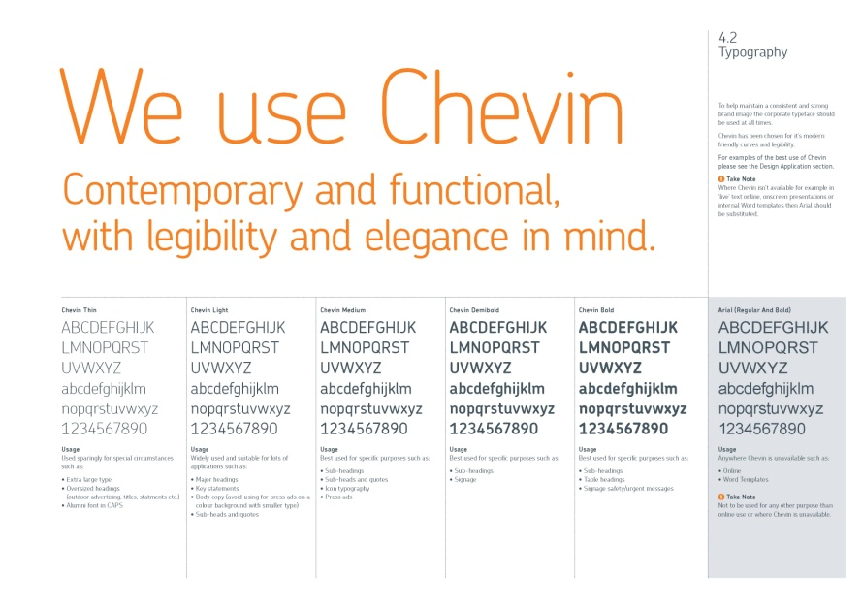
- Who to ask for help. You must make sure you know who to contact for clarification of, for example, spelling. This relates to people’s names, statistics, and ‘turns of phrase’ in the original handwritten document. You also need to know who to turn to internally for help with practical production problems or options. It is good advice to ask for lots of advice in the early stages. In a way, it is expected and most people like to help!
Work Projects
It is a requirement of this Unit that you complete Work Projects as advised by your Trainer. You must submit documentation, suitable evidence or other relevant proof of completion of the project to your Trainer by the agreed date.
1.1 To fulfil the requirements of this Work Project you are asked to identify different technology used in preparing documents
1.2 To fulfil the requirements of this Work Project you are asked to identify potential audiences of documents
1.3 To fulfil the requirements of this Work Project you are asked to identify appropriate persons who may need to be notified or involved during the document production process

Summary

Determine presentation and format of document
Select software appropriate to the nature of the document to be produced
Selecting the right technology and software.
Select appropriate layout and style of document consistent with enterprise guidelines
Types of hospitality documents
Types of generic documents
Potential audiences
Organisational requirements
Document processing tasks.
Discuss format and presentation of document with appropriate person
Appropriate person
Procedures and standards
Writing styles
Clarification of requirements.

Element 2:
Produce document

2.1 Produce document in required style and format

Introduction
If you know how to write well, your correspondence will get results. Good correspondence organises relevant information, identifies the writer’s purpose, and presents it in a way that suits the context.
In Section 1 of this manual a number of common documents that can be prepared have been identified, including some organisational considerations that needed to be taken into consideration.
As mentioned, in this section we will explain some key requirements when preparing each of these.

Recap of office documents
In business, certain types of records, forms and modes of correspondence are used daily. To run a business effectively it is important that you are able to utilise the types of office documents as shown below automatically.

Basic principles of preparing documents

Six steps to good writing

Styles of Letters
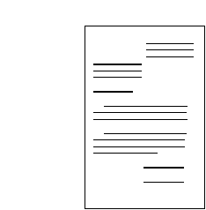
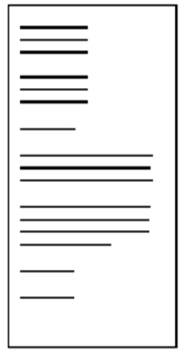
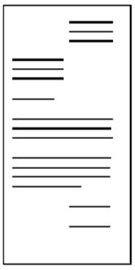

Preparing Letterheads


Essential Parts | Optional Parts
Writer’s name and address | Subject line
Date | Attention line
Inside address | Reference initials
Greeting or salutation | Enclosure
Body of the letter | File number
Complimentary close | Sender’s telephone extension
Writer’s signature and job title or designation

The Complimentary close should match the form of address used in the salutation.
Dear Sir | Dear Ms Pham | Dear Ploy
Yours faithfully | Yours sincerely | Yours sincerely
Preparing Memorandums (Memos)
The main difference between a memo and a letter is that a memo is in-house. It is not sent to people who do not work within the organisation.
Essential Parts | Optional Parts
To  From  Date  Subject | Cc

Preparing Routine Letters
Memo
Date: 19 December 2012
To: Hospitality staff
From: Birgitta March
Re: Work placements

You are invited to a meeting to discuss work placements for our hospitality volunteers for the upcoming New Year's Eve function.

Time: 10 am
Date: 22 December 2012
Where: Meeting room B245, level 3
R.S.V.P: By 21 April 2013
Email: birgittam@angliss.edu.au

I hope you can all attend.
The routine correspondence can be planned in three steps.
Opening Paragraph | Middle Paragraphs | Ending Paragraph
Refer to the communication they sent to you | Provide complete information | Include a goodwill close

- Most routine business letters begin by referring to previous correspondence:
- Here is the information you asked for in your letter of 12 November.
- In your letter of 9 June, you asked for...
- In reply to your letter of 8 August...
Or your letter may be in response to a telephone call or an in-person conversation. Then you might write:
- Following our conversation this morning...
- Your telephone call this morning reminded me that...
- Providing complete information means giving all the necessary details.
This involves trying to answer any possible questions that the reader may want to ask. A bulletin or brochure is a useful way to minimise detail in letters.
- We close our letter with a note of goodwill, to avoid sounding abrupt.
Preparing Good News and Neutral Letters
Opening Paragraph | Middle Paragraphs | Ending Paragraph
Write the good news | Provide relevant detail | Repeat the good news

The opening paragraph can begin with the good news and remove any uncertainty the reader may have about our response to their situation:
- Although the warranty on your heater ended six months ago, we have decided to replace it without further charge
- We overestimated the costs of repairs to your roof. The account will be $700.00 less than we anticipated.
The middle paragraphs of our correspondence provide the reader with detailed explanation of what has taken place.
The final paragraph in the letter can again refer to the good news. Please telephone our office to make a suitable time for our plumber to fit your new heater. Our cheque for seven hundred dollars is enclosed.
This pattern of writing a good news letter is well balanced and leaves our reader with positive thoughts about our product and our company.

Writing Good News or Neutral Letters
The content of different types of positive or neutral letters will vary. Listed below are four different types of good news letter.
- AN INQUIRY | - A REQUEST
A letter of inquiry asks others to share information and ideas | A letter of request seeks a specific action e.g. A purchase order
- AN AKNOWLEDGMENT | - A LETTER OF INTRODUCTION
A letter of acknowledgment acknowledges requests for information, confirms orders, supplies information and thanks the reader. | A letter of introduction aims to maintain contact and create goodwill and the opportunity for future sales or business.
LETTER WRITING STRATEGIES – Good News or Neutral Letters
- Inquiry
- Identify the inquiry in the subject line
- Open with the inquiry and a short background explanation if necessary
- Indicate the need for the receiver to respond
- Close in a courteous and friendly manner.
- Request
- Identify the request in the subject line
- If you choose to omit the subject line, identify the request and give a brief reason or background for the request in the opening paragraph
- Ask for a specific response to the request
- Close courteously to maintain goodwill.
- Letter of acknowledgment
- Start with the acknowledgement
- Say ‘yes’ clearly when relevant
- Supply any necessary information or details
- Close courteously to maintain goodwill.
- Letter of introduction
- Use the subject line to catch the reader’s interest
- Open with a reason for the introduction and aim to catch the reader’s attention and interest
- Use details and information in the middle paragraphs to create a desire to read further
- Close by saying what you can do for the reader and what you want the reader to do
- Letter or request (good news letter) using modified block layout with indented paragraphs.
PARADISE EVENTS
971 Ploenchit Road
Pathumwan, THAILAND 10330
Ph: 1800-578-252

4 February 2012
Aat Yodsuwan
H & R Publishing Group Pty Ltd
1022 Phetchburi Road
Bangkok THAILAND 10400

Dear Aat,
Re: Order for Brochure for Paradise Events
I would like to place an order for the printing of the advertising brochure for Paradise Events.
Our advertising is booked on Order No. 5565, customer No 332345. I have enclosed a proof for the printer to assess the colours. Please return the proofs after the print run.
I would appreciate your prompt handling of this order so that we may have the brochures by 1 March.
Please contact me if you have any questions. I am most happy with your previous work and look forward to receiving this order.
Yours sincerely
Apichart Kan
Manager

Order of information

Subject Line
Identify the request
Background details
Specific response
Courteous close

Preparing Bad News Letters
The bad news letter can be planned in three steps.
Opening Paragraph | Middle Paragraphs | Ending Paragraph
Allude to the situation with a neutral comment. | Give details and reasons.  State the bad news.  Provide workable alternatives. | Close with a neutral or positive statement.

- We start with a statement of fact which is a neutral statement concerning the situation:
- The heating unit that you returned has been checked by our laboratory
- The cost of the repairs to your roof which we originally estimated at $8000 can now be compared with the actual costs of the materials
- We must provide details and reasons before we fully reveal the bad news. We must explain some of the factors that have influenced our decision.
- In the process of installation your heater has received some damage which has stopped the flow of water into the unit. Broken pipes may result from improper positioning during installation or from mistreatment on the pipes once they are in place.
In that same paragraph we then state the bad news
- Consequently we cannot provide the requested coverage at this time.
- Close with a neutral or positive statement.
- We can recommend an excellent tradesman to correctly install one of our new heaters
- Thank you for thinking of us for your heating needs.
Do not close your letter by asking them if you can help them in some other way, since you were not able to help them this time. Avoid the urge to apologise to them in the final paragraph. You have done all that is possible for you to do, so you do not need to apologise.
Writing Bad News Letters
Listed below are four different types of bad news letters and guidelines for writing them.
- ORDER REFUSAL | - SAYING ’NO’ TO A REQUEST FOR CREDIT
An order refusal declines a request | A credit refusal rejects a request for credit
3. REFUSING AN ADJUSTMENT | 4. DECLINING INVITATIONS AND REQUESTS FOR FAVOUR
An adjustment refusal is a request to change, replace or adjust a transaction that has already taken place | An invitation or request refusal

LETTER WRITING STRATEGIES – Bad News Letters:
  - Order refusal
- Start with an acknowledgment of the order
- Give an explanation with reasons that lead to the refusal
- State the refusal
- Close with a positive, courteous paragraph which expresses interest in a continuing relationship with the customer in the future.
  - SAYING ’NO’ TO A REQUEST FOR CREDIT
- Start with a neutral opening or buffer paragraph
- Give an explanation of the factors considered in the decision
- State the refusal clearly and courteously
- Close with a positive, courteous paragraph which invites the receiver to contact your organisation in the future.
  - REFUSING AN ADJUSTMENT
- Start with a buffer paragraph which acknowledges the request for the adjustment
- Give a positive explanation of the reasons for the decision
- State the refusal courteously
- Close with positive language in an attempt to maintain the customer’s goodwill.
  - DECLINING INVITATIONS AND REQUESTS FOR FAVOUR
- Start with a neutral buffer, preferably an appreciation of the invitation or request
- Give an explanation and reasons
- State the refusal clearly, courteously and tactfully
- Close with a positive paragraph which expresses interest in the other person or organisation.

Yen Recruitment Hai Ba Trung Street
Hanoi, VIETNAM 102222-153343
Ph: (03) 9822 3456
yen@yenrecruitment.com

27 February 2012

Ms Dung Pham
2 Cong Quynh St., District 1
Hanoi, VIETNAM 102222-153589

Dear Dung,

Thank you for the time you gave up to attend an interview with Bao Bui recently. Bao enjoyed meeting with you and hopes you found the discussion informative.

We can, of course, only invite a proportion of the candidates we meet to the second interviews. Consequently, our evaluations are made using a number of key criteria. The difference between those selected for follow-up and those who miss out is sometimes marginal. However, with a set number of positions available we hope you will understand the difficulty in making final decisions.

While your application has been given serious consideration, we regret to advise that, on this occasion, we will not be offering you a second interview.

We appreciate your interest in our firm and wish you every success in your future career.

Yours sincerely,

Yen Truong
Personnel Officer

Effective bad news letter refusing employment (full block layout)
Order of information

Neutral buffer
Explanation

Refusal
Positive close

Preparing a Short Report
A short report can describe progress on a project and present information.
The sections of a report can be seen as follows:
- Introduction – clearly identifies at the outset the purpose and subject of the report

- Main body – presents an outline of the issue(s) as well as setting out all central points with information to support and validate claims/assertions
- Conclusion – finalises the report and summarises what has been presented. It also suggests how the information presented can be used, as well as what impact the data is likely to have on operational matters
- Recommendations – draws together all the information, data and statistics in the report and suggests what action should flow from the research. They are optional but are a common aspect of most reports.
Preparing a Long Report
Long reports will provide exhaustive data, and supply informed opinion and advice on a nominated topic, problem or issue.

It is usual for the recipient of a long report to expect detailed information and evidence relating to the issue, informed analysis of the research material, a set of conclusions, and a series of recommendations.
The structure of a long report is:
- Title page – identifying the work, including who prepared the report, and their position, title and qualifications
- Table of contents – listing what is in the report and the page numbers
- Introduction – an overview of what is in the bulk of the report
- An ‘Executive Summary’ may also be included. This is a short form version of the report that distils the essence of the report into a condensed format
- Main body – detailing research undertaken, methodology used, people spoken to, areas visited, literature read
- Conclusions – a summing up of the findings
- Recommendations – a list of suggested actions that should be taken and why
- Bibliography/references – a comprehensive list of the books and articles that were used as the basis for the research and the report.

Preparing Submissions
Submissions are commonly created when you make a request for funds or seek authorisation to amend a current practice, procedure or protocol.
There are three critical elements to any submission, and these must be borne in mind and addressed in the formulation of the submission:

- Define the problem. Outline all elements of the problem that is being faced from all the relevant perspectives so that readers can understand and appreciate the nature and magnitude of the problem
- Define current position. Describe potential impacts and quantify outcomes wherever possible so that the urgency and potential of the issue can be recognised
- Seek authorisation to take action to fix the problem. Outline the proposal to remedy the situation, including timelines, those involved, costs, and eventual benefits.
Submissions require specific, relevant, up to date and accurate information presented in a logical manner. The following is an accepted format:
- Title page. This identifies the name/title of the submission, including who prepared it, and their position, title and qualifications
- Introduction. Gives an overview of the current situation, and/or the problem being faced
- Main body. This is where options to solve the problem are presented
- Conclusion. This is a summing up of the situation and the alternatives that are available
- Recommendation. Makes suggestions on the next step or solution
- Space for signatures and approval. This is the place for signatures from those who are authorised to tender such submissions.
Preparing Proposals
You may be required to produce a proposal, especially where the property is proactive in its approaches to various market segments, authorities or strategic partners.
A useful format or structure is as follows:
- Cover page – identifying name/title, who prepared it, position, title and qualifications
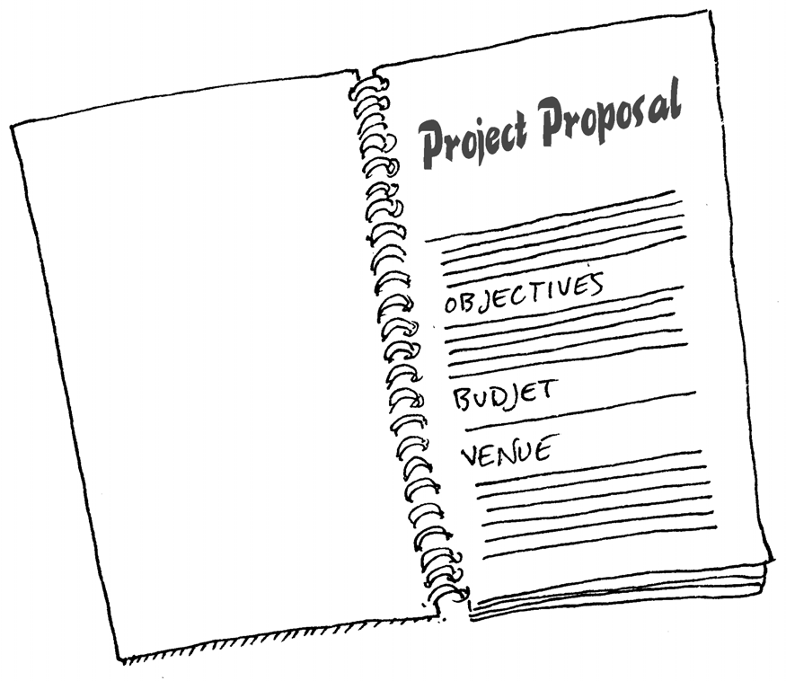
- Executive Summary – condensed summary of the work
- Introduction – giving purpose of proposal
- Description of management of the project – naming those who were involved and their individual roles and responsibilities
- Description of qualifications and experience of the organisation/individuals responsible for the project/proposal
- Outline of the budget – explaining how much is intended to be allocated for each section of the proposal
- Proposed schedule – identification of relevant timelines
- Description of terms and conditions – detailed explanation of the parameters of the proposal
- Summary – an overview of what is being proposed together with the benefits to all concerned
- Attachments and appendices – a full grouping of all attendant documentation that is deemed necessary to explain and validate the proposal.
Preparing Tenders
You may be asked to respond formally to a request to provide various goods and services. This may follow a formal Request for Tender document. These RFTs will stipulate the exact nature of any tenders that are to be put in.
In the absence of an RFT document, the following comprise an acceptable format for a tender:

- The purpose of the project. This is a restatement of the objectives of the tender, proving to the reader that you understand what it is they are after
- Your ability to meet the project objectives. These are statements and evidence that seek to prove that your organisation has the experience, ability and capacity to fill the needs of the tender. You may refer to previous similar undertakings that you have successfully completed, provide statements about the qualifications of staff, and outline the breadth and depth of physical resources that the establishment can marshal
- The budget. This is a detailed explanation and breakdown of the costs involved, and the final tender price that you are submitting
- Funding conditions and conditions of payment. This tells the recipient how you want to be paid, how much is to paid at the outset, what percentage is to be paid at nominated stages throughout the execution of the tender or contract
- The timeframe for completion. This will set out when the project will be finally completed, describing progressive dates or milestones for achievement along the way.

Adding a signature
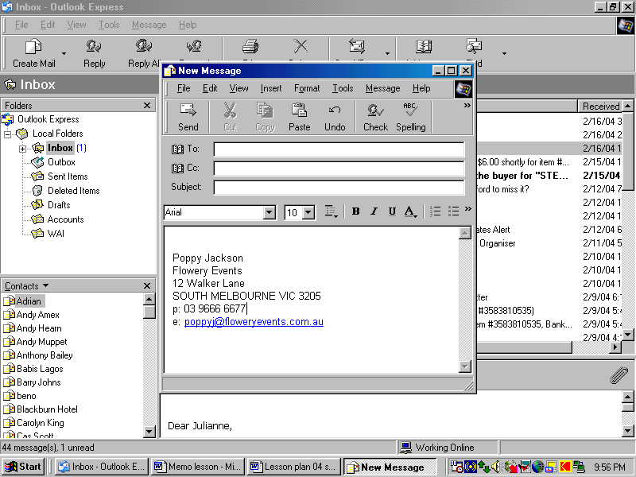
Add a Signature to Email in Microsoft Outlook
- Open Microsoft Outlook. This can be done from a shortcut on the desktop, from the Start menu or from the Quick Launch Bar if you have enabled it on the taskbar
- Click the "Tools" menu on the menu bar
- Click "Options"
- Click on the "General" tab
- Click the "Email Options" link
- Click the "Email Signatures" tab
- Enter the title of the signature in the title box. The title of the signature is important, especially if you plan on using more than one signature for your emails (one for personal emails, one for professional, one for fun etc.)
- Fill in the body of the signature in the text field titled "Create your email signature." Here you can include plain text, as well as pictures, animated images (in the form of HTML links) and anything else that can be displayed in a HTML enabled email server
- Click "Add" to finalize the signature
- Click the "New" button to create another signature. You can simply repeat steps 7, 8 and 9 to complete the process. You may continue to add signatures until you are done.
  - Source: http://www.ehow.com/how_2048574_add-signature-email.html#ixzz1Ts6EJKYE

2.2 Produce document within designated timelines

Introduction
Regardless of how a document is to be prepared, one of the most important considerations is that it is produced within the timeframes of the intended audience.
Types of timelines
The timelines within which documents will need to be prepared may be:
Immediately
In the case of urgent faxes, correspondence, quotes and letters for clients who are using the facilities for conventions etc.
By a set date
This applies to agendas, minutes and reports. It may often also fall to you to chase up people who are supposed to have their handwritten material to you by a set date/ and time so that you can type it up.
Managers are often very involved with other work, and preparing written reports can and does fall very far down their list of things to be done.
You may start off by following up these people for their information. Afterwards this will quickly develop into standard operating procedure and when you don’t do it, they can get very upset! They get to rely on you to keep them up to the mark.
Other correspondence that falls into this category may be responses to certain government or semi-government bodies. Many of these require a response by a given date.
No hurry
Many items that come your way will be accompanied by a verbal or written remark that there is no urgency attached to them. The person may say “anytime this week is fine’, “whenever you can do it”.
These are often standard letters, and form replies.
Timing considerations
Each document that needs to be prepared should be awarded a suitable amount of time to:
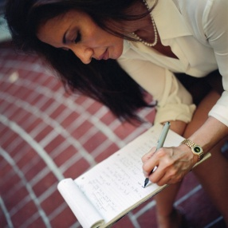
- Conduct necessary research to compile information
- Hold relevant meetings and discussions required
- Type the actual document. The minimum international standard for competency in speed and accuracy for typing are 30 – 35 words per minute with 95% – 98% accuracy
- Review and collect feedback
- Distribute or transport final document.
2.3 Save document regularly to avoid loss of data

Introduction
In most cases you will be required to save any work done in a file.
Saving and closing must become second nature, as should backing up any work that has been done.

This may simply mean copying the work to one of the storage mediums mentioned below.
In some cases, you will receive an error message when printing certain documents that require you to close documents to enable the printing process to begin.
Some workplaces require staff to save and close all documents if they have to leave their workstations. Other premises require staff to lock their workstation if they need to leave their desk. Locking the PC requires a password to be entered before access can be regained.
Administrators and managers will have override codes or passwords that enable them to access any locked computers.
Storing data
It takes lots of time, money and effort to enter data into computers, and that information must be safeguarded.
If the data is lost it is highly unlikely that it can all be remembered, or that it will all be able to be reproduced. Therefore appropriate storage is critical.

While many operators are competent in opening, saving and closing files, it is frightening how few people are familiar with enterprise requirements for storing data. There seems to be a belief among too many staff that 'it won't happen to me'. They seem to believe that it is only other people's computers that crash, only other people's computers that get attacked by viruses/bugs, become corrupted or get stolen, or 'perish' in a fire.
The workplace reality is that storing data is as important as generating it in the first place.

Methods to store data
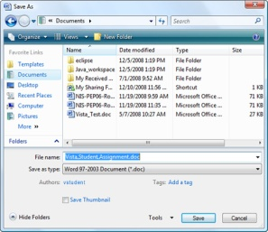
After creating or amending files, documents and records it is important that you are able to store data appropriately, and then exit the applications without damage, and without loss of data.
This storage of data may include:
- Storage in directories and sub-directories. These may be allocated random names or titles, but most large establishments have specified policies and procedures regarding this
- Storage on hard drive. This is the most common form of saving, and is simply saving and storing data on the computer’s hard drive ‘c: drive’. Most premises do this, and many small operations don’t bother backing up this option.
If there is a fire, theft, industrial espionage or a simple hard drive crash or corruption the results can be catastrophic.
It is true that no-one can understand how damaging, how infuriating or how shattering a total hard drive loss is, unless they have experienced one

- Storage on networked computers. Some properties back-up data on other hard drives within the network. This means that front office (located, say, on the ground floor in the lobby) will send their data to the housekeeping PC (located on the 4th floor), via a networked application, for storage there
- Storage of memory sticks. These small devices can hold large amounts of files on a small and relatively cheap piece of equipment. Memory sticks are a great way to transport pieces of information and to provide it to others
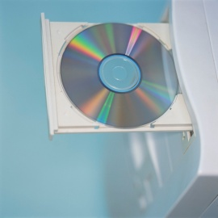
- Storage on CD-ROMs. Whilst it is becoming outdated, some establishments may use are CD-ROMs (Compact Disk Read-Only Memory) for storage of data. A CD writer or burner can be used to write and store data easily from the hard drive on to CD-ROMs. This may still be used as a cheap method to distribute electronic copies of information
- Storage on portable hard drives. Many individuals may have external hard drives that can hold large amounts of information. Again this may be a suitable back up source
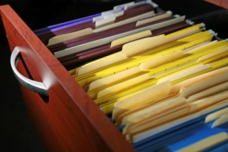
- Appropriate storage and filing of hard copies of computer generated documents. In some cases a hard copy of data may be taken and filed or archived for future use. While hard copies cannot be readily amended (unless retyped into the computer, or scanned in) they at least provide a source document for future reference.
Hard copies may not be very ‘high tech’ but it is amazing how valuable they become when the hard drive crashes, or there is a power or other failure and the data from the hard drive is unavailable.
2.4 Information from same or other software packages is integrated as required

Introduction
Different computer software systems and programs may have different functions or applications that differ from that of others. This may affect a range of tasks that can be performed, how documents may appear or how they can be saved.
It is essential that when collecting or integrating documents themselves or information contained within these documents, that vital information and the look of the document is not diminished.
Types of software functions
Different software programs may have a number of software functions that need to be considered when transferring documents including:
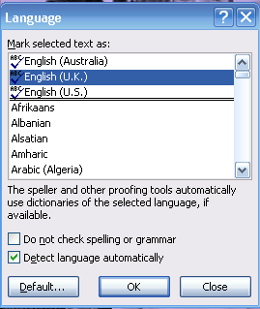
- Default settings
- Page setup
- Paragraph formatting
- Text formatting
- Tabs
- Line spacing
- Page numbering
- Headers and/or footers
- Application of spell check
- Indenting
- Document protection protocols.

2.5 Proof read draft document prior to printing

Introduction
It is essential that the document that you have prepared is not only appropriate but also professional. As it is will be reflection of both your company and yourself, it must be presented in the best possible light.

It is essential that any document is proof read before being distributed to its intended audience.
Principles of proof reading
Proofread may relate to:
- Utilise spell check function of software
- Utilise grammar check function of software
- Check page break placement
- Check hard copy of document
- Check soft copy of document.
The rule of "7 Cs"
When writing Business Correspondence we generally consider the rule of the “7 Cs ". This means that all of your work should be:
- Clear - able to be understood in one reading by the recipient (time = money)
- Concise - conveying what has to be stated with a minimum of words, sentences and paragraphs
- Complete - all of the information necessary to understand the correspondence is passed on
- Correct - all of the information conveyed is accurate
- Courteous - your tone is always polite as you are representing your organisation and wish to create goodwill
- Clean - this means that there are no coffee stains, liquid paper, or crossing out on your correspondence. It also means that your work is not cluttered and there is plenty of white space so that the document looks appealing and professional
- Checked - this means your work has been examined for spelling mistakes, grammatical mistakes, format and layout and found to be mistake-free.
At this proof reading time, it is important to reflect on these ‘7 C’s’ and ensure that the document reflects these.

Ensure text is without spelling, punctuation and/or grammatical errors
Good workplace writing results from thoughtful planning, writing in plain English and careful editing. Each stage is part of the writing process.
At the planning stage, take time to identify your purpose, consider your receiver, decide what you want to say and put this in a logical sequence.
At the editing stage check your work for accuracy and completeness and make sure that your writing is logical, clear and concise.
At the writing stage, your tools are words, sentences, paragraphs and layout. Make sure you convey your meaning concisely and courteously. The receiver of business correspondence wants to understand what should happen, why it should happen and how to go about making it happen.
The main purpose when writing in plain English is to get the message across.
Checking spelling
It is essential spelling is correct. There are a number of tools that can help to ensure this is done in a thorough manner.
Dictionaries:
- www.dictionary.com
- www.thefreedictionary.com
- www.thesaurus.com

- www.macquariedictionary.com.au.




Running a spell check
The first thing you must do when you have completed your draft document is to do a spell check. However, beware that spell checkers are not totally accurate. You may need a dictionary, as identified above. You will need to add new words when you are sure you have spelled them correctly.
Step 1: On the Review tab, click the Spelling & Grammar button.
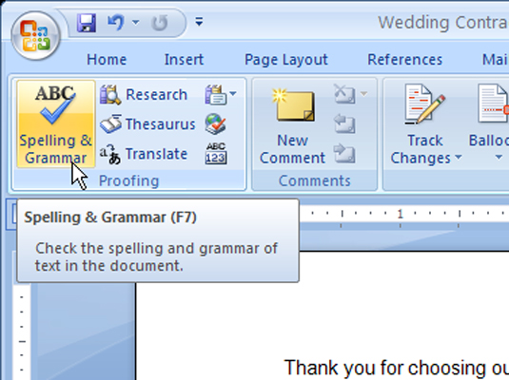
Kitchen inventory as at

Step 2: choose correct word
Step 3: add new word to your dictionary, where appropriate
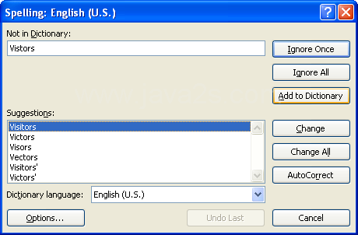

Follow spelling rules
- Use ‘ise’ not ‘ize’ e.g. we organise (not organize)
- Capitals: at beginning of proper nouns, beginning of sentences. Do not capitalise all your writing as it can be interpreted as yelling
- Numbers: write them as figures (5, 10) except for at the start of sentences
- ‘I before e’ except after c’ rule: this works only when the pronunciation of the word is like a long ‘ee’ for example: piece, niece but exceptions are receive, receipt
- Doubling the consonant: For most words with a short vowel sound, ending with a single consonant, double the consonant when adding a suffix that starts with a vowel, such as er, ed or ing. For example: biggest, hotter, and travelling. Exceptions: Some words ending in r, x, w or y are exceptions to the doubling rule:
 | tear + ing | tearing
 | vow + ing | vowing
- If your main word has two consonants at the end, or more than one vowel, don't double the consonant for example: raining, keeper
- Word endings in –ce/-ge: When you want to add a suffix starting with ‘a’ or ‘o’ leave the e in. For example: manageable, noticeable. Exception: prestigious
- Word endings in –ie: When you want to add ing to verbs ending in ie, drop the e and change the i to a y. For example: die – dying, lie – lying, tie – tying
- Words ending in –y after a consonant: When you want to add suffixes such -as, -ed, -es, - er, -eth, -ly, -ness, -ful and -ous to a word ending in y after a consonant, change the y to an i before adding the suffix. For example:
 | eighty + eth | eightieth
 | duty + es | duties
 | lazy + ness | laziness
 | mystery +ous | mysterious
 | beauty + ful | beautiful
- Words ending in –y after a vowel: keep the y when adding suffices such as er, ing or ed. For example:
 | play | playing | played
 | buy | buying | buyer
 | play | playing | player
- Appendices: should be numbered
- Attachments: external documents that should not be included in the body of the document.
Omit unnecessary words
As mentioned above, two of the “7 C’s” is clear and concise. It is important when proofing the document that it is presented in a manner that is not too lengthy.
It may be wise to change words or phrases to ensure they are concise and easy to read by the intended audience.
The following are some examples of how to make necessary changes.
Too wordy | Better option
As of now | Now
At a price of $20 | $20
We can supply them in the following colours: blue, green and yellow | We can supply them in blue, green and yellow
We seldom ever make this mistake | We seldom make this mistake
In my personal opinion | In my opinion
In the event that | If
During the month of April | During April
For the reason that | Because
During which time | While
We are of the opinion | We believe
At the present time | Now
In the majority of instances | Mostly
According to our records | We find
On a regular basis | Regularly
He is sorry for | He regrets
He has no confidence in | He doubts
She is in accord with | She agrees
In the near future | Soon

Correct use of punctuation marks
Punctuation marks serve to indicate the structure and organisation of writing, as well as intonation and pauses to be observed when reading it aloud.
. | Full stop | Commonly placed at the end of several different types of sentences in English and many other languages.
, | Comma | Used in many contexts, principally for separating things
: | Colon | A colon informs the reader that what follows proves, clarifies, explains, or simply enumerates elements of what is referred to before.
; | Semicolon | The mark to separate words opposed in meaning and to mark off interdependent statements.[
‘ | Single quotation mark | Used in pairs to set off speech, a quotation, a phrase or a word.  Also known as inverted comma.
“ ” | Double quotation mark | Used in pairs to set off speech, a quotation, a phrase or a word.  Also known as an inverted comma.
( ) | Brackets | To set apart or interject text within other text  Four main types of brackets:  Round brackets or parentheses: ( )  Square brackets or box brackets: [ ]  Curly brackets: { } Angle brackets: ⟨ ⟩
! | Exclamation mark | It is usually used after an interjection or exclamation to indicate strong feelings or high volume, and generally marks the end of a sentence.
? | Question mark | Question point or query is a punctuation mark that replaces the full stop at the end of an interrogative sentence.

Work Projects
It is a requirement of this Unit that you complete Work Projects as advised by your Trainer. You must submit documentation, suitable evidence or other relevant proof of completion of the project to your Trainer by the agreed date.
2.1 To fulfil the requirements of this Work Project you are asked to identify a list of various documents that are commonly produced in the hospitality industry
2.2. To fulfil the requirements of this Work Project you are asked to identify different types of timelines that affect document production
2.3. To fulfil the requirements of this Work Project you are asked to identify methods to store data
2.4. To fulfil the requirements of this Work Project you are asked to identify some software functions that may differ between software packages
2.5 To fulfil the requirements of this Work Project you are asked to identify the principles of proof reading

Summary

Produce document
Produce document in required style and format
Recap of office documents
Basic principles of preparing documents
Six steps to good writing
Styles of Letters
Preparing Letterheads
Preparing Memorandums (Memos)
Preparing Routine Letters
Preparing Good News and Neutral Letters
Preparing Bad News Letters
Preparing a Short Report
Preparing a Long Report
Preparing Submissions
Preparing Proposals
Preparing Tenders
Adding a signature.
Produce document within designated timelines
Types of timelines
Timing considerations.
Save document regularly to avoid loss of data
Storing data
Methods to store data.
Information from same or other software packages is integrated as required
Types of software functions.
Proof read draft document prior to printing
Principles of proof reading
The rule of "7 Cs"
Ensure text is without spelling, punctuation and/or grammatical errors
Checking spelling
Omit unnecessary words
Correct use of punctuation marks.

Element 3:
Print and deliver document

3.1 Utilise printing function

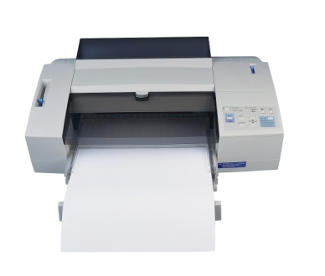
Introduction
Now that the document has been prepared it is now time to print and review to ensure that it is ready for distribution to the intended audience.
Not only is printing an essential element when distributing hard copy documents to others, but serves as a valuable tool for proof reading and to conduct a final check before printing final copies.
Check printer
To print documents from a computer, a printer has to be attached.
The type and brand of printer found in the front office will vary from establishment to establishment, but all printers work in relatively the same manner.
Printers often need to be connected to the computer via cables, and every printer will need to be stocked with paper, which will require replenishing from time to time.
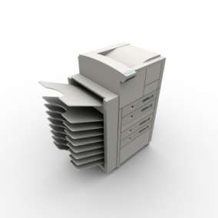
Most printers use A4 paper, which is the standard letter size.
Be aware that some colour printers require special paper.
Some printers may require paper to be loaded into a tray at the top of the printer, while others require paper to be loaded into a tray near the base of the printer – similar to the paper loading functions on a photocopier.
The paper should always be fanned before being placed into the feed bin or slot. This action separates the individual sheets of paper and thus avoids paper being stuck together and causing a jam in the printer.
Note: before operating office equipment, or replacing parts (toner and paper), it is vital to become familiar with the correct operating instructions as set out in the operator’s manual.
Print preview
Using the Print Preview facility can help to identify areas that require attention before the final article is printed. However, many people cannot fully appreciate the correspondence or document until they have a hard copy to look at.
Print Previews can be useful for positioning the letter on the page, especially where it is a short letter, and they can be helpful in determining overall balance and layout.

Printing from Word
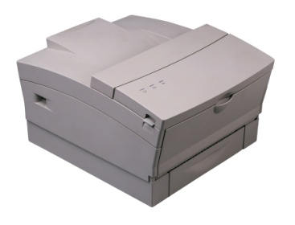
There are three methods that can be used to print from Word:
- File Menu option
- Printer icon
- Shortcut key Ctrl-P.
Steps to printing
- Open Personal_Computers.docx
- Click File>Print and the print options page will occur.
- There is a preview of the current page shown on the right.
- The 'copies' box allows you to specify the number of copies.
The printer allows you to change the printer as a business may have different printers for different situations.
Settings allow you to print all pages, the current page as shown on the right, or a custom range of pages, or the document properties. By clicking on the arrows on the lower right side the current page can be changed for the “Print current page” option.
If the selected printer has the capabilities, there will be an option to allow double-sided or duplex printing.
'Collated' applies when there is more than one copy to print and the copy has more than one page. Assume that four copies of a document that has 3 pages and double-sided printing has been selected, which means there will be two pieces of paper with printing on three sides. Collated will print the entire document four times. Uncollated will print four copies of the first page and second page on one piece of paper and then four copies of the last page.
'Orientation' (Portrait or Landscape) determines how the page will be laid out. Portrait has the long edge on the vertical, much like a portrait painting, or this page on the computer screen. Landscape will have the short edge on the vertical and the long edge across, much like a landscape painting.
Margins provide the opportunity to set the beginning and ending position of text on the page from the edge of the paper.
Pages per sheet will print smaller text and images on the page to fit more on the paper.
Ensure one copy has been selected and click on the print button to print the page.
Click the Home tab. Select the first paragraph and click on the ‘File Menu>Print’. The Settings will now have an option to print the selected text. Print the selected text.

3.2 Proofread document

Introduction
Different workplaces have different requirements. This doesn’t mean that one is right and one is wrong. They’re just different and you have to conform to in–house practices.
The following is indicative of the requirements that may need to be observed when writing and proof reading basic letters, memos, or reports.
Section 2.5 explored the concept of proof reading before printing the document. This section will look at some additional proof reading requirements and activities.
Proof reading requirements
- Check the finished article. It should be of clear and concise construction
- Check the sequencing. What you have said should be logical in sequence
- Check layout. The presentation of paragraphs and their content should also be logical and definitive
- Check the attachments. These should be included where appropriate and a ‘with compliments’ slip used where appropriate
- Check the mailing details. Ensure correct spelling of names of people and organisations, correct mailing address, correct title
- Check the spelling and grammar. Use the computer facilities for these, although a thorough and personal reading of the document is always recommended. Spell checks only check the spelling; they don’t let you know if the wrong word has been used. It’s always a good idea to get someone who didn’t write the letter to read it. This should be mandatory where the letter is important
- Observe confidentiality. Privacy and related issues must be observed at all times.

Any amendments should be made as soon as they are identified, or there is the risk they will be forgotten and the wrong letter may be mailed out.
Likewise, any initial letters that are amended must be destroyed immediately to prevent the risk of a superseded letter being sent.
In many cases, the draft that you produce and send off for final authorisation may well be 100% perfect but will frequently come back to you for amendment. Often the person requiring the letter will have rethought a portion of the correspondence in the intervening period and, while there are no technical mistakes in the document, will require you to make changes.

Collective advice from others
Before printing the final document it is important to seek advice and comment from other persons. As the writer has spent considerable time preparing the document, they may miss a number of key issues in relation to the document which can only be noticed through the use of ‘fresh eyes’.
Purpose of presenting and circulating documents

As previously mentioned, a writer may wish to present a document in draft format to gain feedback and suggestions for improvement.
Issues that may be overlooked may include:
- Purpose and flow
- Content
- Spelling, grammar and punctuation
- Layout and style
- Smooth flow of the document
- Accurate comments and use of data
- Referencing of data and statistics
- Recommendations or action required.
Methods of presenting and circulating documents
There are a number of ways to circulate documentation. However it is important to first notify the reader of the following:
- Introduction of the document
- Purpose of document
- Action required by the reader.
The following are methods used to circulate documentation:
- Mail
- Email
- Fax
- By hand
- Courier
- As an accompaniment to an oral presentation.

3.3 Make any necessary modifications to document to improve appearance and meet required specification/s

Introduction
Once a document has been printed in a draft format, it certainly makes it easier for the writer to see how the finished document will look for the intended audience.
Whilst spelling and grammatical changes would have taken place by now, it is a good time to make any medications to the document to enhance its visual appeal and professionalism.

Types of modifications
One important aspect is to ensure that the layout and visual appeal of a document is suitable to the intended audience. With this in mind, possible changes that can be made include:
- Changing information within document
- Streamlining wording
- Change page size and orientation
- Change page margins
- Add/delete columns
- Formatting including alignment and line spacing, font size, indents, font colours, outside borders, bullets, numbering
- Copying, cutting and pasting

- Inserting page breaks and section breaks
- Inserting or changing headers and footers
- Inserting page numbers
- Adding styles
- Inserting and formatting tables
- Saving documents
- Inserting images and graphics/clip art
- Inserting smart art and shapes
- Check spelling and grammar
- Attaching documents
- Saving and naming documents
- Copying files/folders
- Setting up the correct printer.

3.4 Print and present documents according to requirements

Introduction
Now that all necessary amendments have been made to documents it is now time to print the final copy and to undertake any additional activities that are associated with getting the document and any appropriate supplementary materials to the intended audience.
This section will identify some activities that are to be conducted after the final copy of a document has been printed.
Organisational requirements

Preparing the correspondence and other documentation mentioned is only part of the job. In many cases your role will also include:
- Producing multiple copies
- Collating documents
- Adding attachments – briefing papers, reports and other materials
- Binding
- Mailing
- Disseminating internally
- Recording dissemination in a file or book
- Filing – hard copy and computer based.
Some of these activities will be explained in more detail in this section.
Preparing for signature and posting
The following points should be noted. However, organisational requirements must be checked to determine if they differ:
- Staff who have entirely developed and written the letter themselves will usually sign it themselves
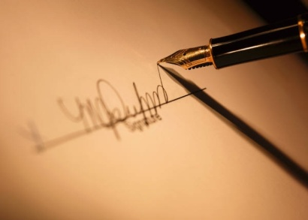
- Where management has to give final approval, a typed envelope should accompany the letter. This allows them to sign the letter and put it in the envelope safe in the knowledge that nothing further will happen to it
- It is common practice for a duplicate copy of the letter to accompany the draft for approval
- Different people have different ways of putting their name, initials and title at the close of the letter.
In addition, the writer may have 'letters' after their name that they want included on certain letters but omitted on others.

Attaching enclosures
- It is common practice when anything is enclosed or attached to the letter to type 'Encl.' at the bottom left-hand side of the last page of letter
- Select an envelope large enough to comfortably accept enclosures
- A 'with compliments' slip may be attached
- Adjust where necessary, and seek advice or comment from relevant others where appropriate.

Folding an envelope
DL Envelope
110mm x 220mm - standard, business sized envelope. Designed to fit 1/3 of an A4 sheet. (Post Office Preferred.)
Fold the letter twice so that it is creased to make thirds. This will fit easily in a standard envelope, and it is easy to unfold.
The address of the recipient is in the middle of the envelope, beginning approximately halfway down. (Be sure it is mostly below the stamp, or it may get covered over by the cancellation.)
The return address is in the upper left-hand corner. This is not necessary to type in if the stationery is pre-printed with the return address.
If you are using business envelopes with a window, fold the letter so that the inside address shows through the window.
Some correspondents include an attention line near the lower left corner for routing purposes. This is normally part of the main address unless space is a factor. It may be a department or a person's name. For example: Attn.: returns dept.
To type an envelope in Microsoft Word, go to ‘mailings’ tab, ‘create envelope’, then enter the delivery address and return address details.
Full name
Return address 1
Return address 2
Company name (if applicable)
Attn.: name/department
Recipient address 1
Recipient address 2
Postcode
Folding a standard letter
A business letter is folded twice into horizontal thirds and placed into an envelope.
This ensures a little privacy in the letter. The letter is also easy to unfold after opening the envelope.
The following diagram shows how a letter is normally folded. This type of fold is used regardless of letter style:
- Begin with the first page of the letter facing towards you
- Crease the letter along a fold one-third from the bottom. Fold the letter up to a point one-third from the top, covering the writing on the letter
- Make a second horizontal crease one-third from the top of the letter where the bottom of the letter had been folded to
- Tuck the bottom into this crease and fold the top over it. The letter will be folded into thirds. It will fit any standard envelope.
If the letter needs to have the address face out an envelope window, make the second fold in the same location but opposite direction. The letter will then be folded in a Z shape and the address can be positioned to face out the window of the envelope.
 |  | 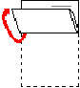

Work Projects
It is a requirement of this Unit that you complete Work Projects as advised by your Trainer. You must submit documentation, suitable evidence or other relevant proof of completion of the project to your Trainer by the agreed date.
3.1 To fulfil the requirements of this Work Project you are asked to identify how to print documents and the purposes of undertaking printing
3.2. To fulfil the requirements of this Work Project you are asked to identify the areas of importance when proof reading documents
3.3. To fulfil the requirements of this Work Project you are asked to identify different modifications that can be made to a document as a result of the proof reading process
3.4. To fulfil the requirements of this Work Project you are asked to identify the additional tasks in getting documents ready for distribution to the intended audience

Summary

Print and deliver document
Utilise printing function
Check printer
Print preview
Printing from Word.
Proofread document
Proof reading requirements
Collective advice from others.
Make any necessary modifications to document to improve appearance and meet required specifications
Types of modifications.
Print and present documents according to requirements
Organisational requirements
Preparing for signature and posting
Attaching enclosures
Folding an envelope
Folding a standard letter.

Presentation of written work

1. Introduction
It is important for students to present carefully prepared written work. Written presentation in industry must be professional in appearance and accurate in content. If students develop good writing skills whilst studying, they are able to easily transfer those skills to the workplace.

2. Style

Students should write in a style that is simple and concise. Short sentences and paragraphs are easier to read and understand. It helps to write a plan and at least one draft of the written work so that the final product will be well organised. The points presented will then follow a logical sequence and be relevant. Students should frequently refer to the question asked, to keep ‘on track’. Teachers recognise and are critical of work that does not answer the question, or is ‘padded’ with irrelevant material. In summary, remember to:
- Plan ahead
- Be clear and concise
- Answer the question
- Proofread the final draft.

3. Presenting Written Work
Types of written work
Students may be asked to write:
- Short and long reports
- Essays
- Records of interviews
- Questionnaires
- Business letters
- Resumes.
Format
All written work should be presented on A4 paper, single-sided with a left-hand margin. If work is word-processed, one-and-a-half or double spacing should be used. Handwritten work must be legible and should also be well spaced to allow for ease of reading. New paragraphs should not be indented but should be separated by a space. Pages must be numbered. If headings are also to be numbered, students should use a logical and sequential system of numbering.
Cover Sheet
All written work should be submitted with a cover sheet stapled to the front that contains:
- The student’s name and student number
- The name of the class/unit
- The due date of the work
- The title of the work
- The teacher’s name
- A signed declaration that the work does not involve plagiarism.
Keeping a Copy
Students must keep a copy of the written work in case it is lost. This rarely happens but it can be disastrous if a copy has not been kept.
Inclusive language
This means language that includes every section of the population. For instance, if a student were to write ‘A nurse is responsible for the patients in her care at all times’ it would be implying that all nurses are female and would be excluding male nurses.
Examples of appropriate language are shown on the right:
Mankind | Humankind
Barman/maid | Bar attendant
Host/hostess | Host
Waiter/waitress | Waiter or waiting staff

Recommended reading
Appleman, Jack; 2008 (1st edition); 10 Steps to Successful Business Writing; ASTD Press
Fisher Chan, Janis; 2008 (Updated edition); E-mail: A Write It Well Guide; Write It Well
Lindsell-Roberts, Sheryl; 2009 (1st edition); Strategic Business Letters and E-mail; Houghton Mifflin
Bond, Alan; 2010 (3rd edition); 300+ Successful Business Letters for All Occasions; Barron's Educational Series

Trainee evaluation sheet

Produce documents, reports and worksheets on a computer
The following statements are about the competency you have just completed.
Please tick the appropriate box | Agree | Don’t Know | Do Not Agree | Does Not Apply
There was too much in this competency to cover without rushing.
Most of the competency seemed relevant to me.
The competency was at the right level for me.
I got enough help from my trainer.
The amount of activities was sufficient.
The competency allowed me to use my own initiative.
My training was well-organised.
My trainer had time to answer my questions.
I understood how I was going to be assessed.
I was given enough time to practice.
My trainer feedback was useful.
Enough equipment was available and it worked well.

The best things about this unit were:

The worst things about this unit were:

The things you should change in this unit are:

Trainee self-assessment checklist
As an indicator to your Trainer/Assessor of your readiness for assessment in this unit please complete the following and hand to your Trainer/Assessor.

Produce documents, reports and worksheets on a computer
 |  | Yes | No*
Element 1: Determine presentation and format of document
1.1 | Select software appropriate to the nature of the document to be produced
1.2 | Select appropriate layout and style of document consistent with enterprise guidelines
1.3 | Discuss format and presentation of document with appropriate person
Element 2: Produce document
2.1 | Produce document in required style and format
2.2 | Produce document within designated timelines
2.3 | Save document regularly to avoid loss of data
2.4 | Information from same or other software packages is integrated as required
2.5 | Proof read draft document prior to printing
Element 3: Print and deliver document
3.1 | Utilise printing function
3.2 | Proofread document
3.3 | Make any necessary modifications to document to improve appearance and meet required specification/s
3.4 | Print and present documents according to requirements

Statement by Trainee:
I believe I am ready to be assessed on the following as indicated above:
Signed: _____________________________ | Date: ____________
Note:
For all boxes where a No* is ticked, please provide details of the extra steps or work you need to do to become ready for assessment.





